AI and Social Media Analysis to Detect Fake News - Project Report

1. Introduction
Fake news poses a significant challenge in the era of social media, where misinformation spreads rapidly. In this project, we develop an AI-driven pipeline for detecting fake news based on news headlines using Natural Language Processing (NLP). We follow a two-stage approach: traditional Machine Learning (ML) and Deep Learning (DL) using LSTM.

2. Dataset
We used the PolitiFact subset of the FakeNewsNet dataset. The dataset includes two CSV files:
- politifact_real.csv: containing real news articles
- politifact_fake.csv: containing fake news articles
Each record contains fields such as 'id', 'news_url', 'title', 'tweet_ids', and 'label'. We only use the 'title' and add a binary label (1 = fake, 0 = real) for classification.
We combine both datasets into one and shuffle the data for unbiased model training.
# AI and Social Media Analysis to Detect Fake News
# Author: Mehrab Gul
# Student ID: 22322449

import pandas as pd

# Paths to the files
fake_path = "../datasets/fake_news_detection/politifact_fake.csv"
real_path = "../datasets/fake_news_detection/politifact_real.csv"

# Load CSV files
df_fake = pd.read_csv(fake_path)
df_real = pd.read_csv(real_path)

# Add labels: 1 for fake, 0 for real
df_fake['label'] = 1
df_real['label'] = 0

# Combine both datasets
df = pd.concat([df_fake, df_real], ignore_index=True)

# Shuffle the combined DataFrame
df = df.sample(frac=1, random_state=42).reset_index(drop=True)

# Display shape and first few rows
print(f"Dataset shape: {df.shape}")
print(df.head())

# the dataset having columns such as id(not needed), news_url(not needed), title(using for fake news classification),
# tweet_ids(not needed), label(requiring for the training)

Output:

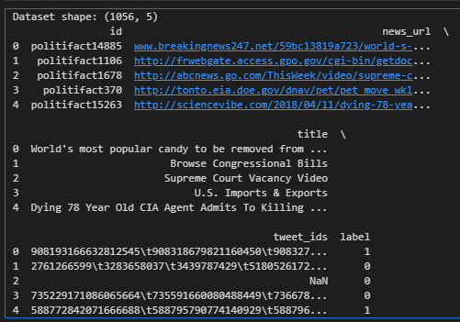

3. Text Preprocessing
We apply standard NLP preprocessing to the news titles:
- Lowercasing text
- Removing URLs, punctuation, numbers
- Removing stopwords
- Lemmatizing words
This prepares the text for vectorization and model input.
import re
import string
import nltk
from nltk.corpus import stopwords
from nltk.stem import WordNetLemmatizer

stop_words = set(stopwords.words('english'))
lemmatizer = WordNetLemmatizer()

def preprocess(text):
text = text.lower()
text = re.sub(r"http\S+|www\S+", "", text) # remove URLs
text = re.sub(r"\d+", "", text) # remove numbers
text = text.translate(str.maketrans("", "", string.punctuation)) # remove punctuation
words = text.split()
words = [lemmatizer.lemmatize(word) for word in words if word not in stop_words]
return " ".join(words)

# Apply preprocessing
df['clean_title'] = df['title'].apply(preprocess)

# Preview
df[['title', 'clean_title', 'label']].head()

Output:


4. Machine Learning Approach
We first used TF-IDF to convert text into numerical vectors, and then trained a Logistic Regression model.
Steps included:
1. TF-IDF Vectorization (max_features=5000)
2. Train-test split (80-20)
3. Training Logistic Regression
4. Evaluating model with accuracy and classification report
# convert text to Vector (TF-IDF)
from sklearn.feature_extraction.text import TfidfVectorizer

vectorizer = TfidfVectorizer(max_features=5000)
X = vectorizer.fit_transform(df['clean_title']) # input features
y = df['label'] # target
# Train test split
from sklearn.model_selection import train_test_split

X_train, X_test, y_train, y_test = train_test_split(X, y, test_size=0.2, random_state=42)
# train a logistic regression model first - ML based approach
from sklearn.linear_model import LogisticRegression
from sklearn.metrics import classification_report, accuracy_score

model = LogisticRegression()
model.fit(X_train, y_train)

y_pred = model.predict(X_test)
print("Accuracy:", accuracy_score(y_test, y_pred))
print(classification_report(y_test, y_pred))
Output:
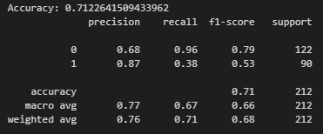
Result:
- Accuracy: ~71%
- High recall for real news, low recall for fake news
- Low confidence in many predictions (e.g., 55-60%)
# prediction/evaluate the model on the new news
def predict_fake_news(headline):
clean_text = preprocess(headline)
vec = vectorizer.transform([clean_text]) # transform to TF-IDF
pred = model.predict(vec)[0]
proba = model.predict_proba(vec)[0][pred]
label = "FAKE" if pred == 1 else "REAL"
print(f"Prediction: {label} (Confidence: {proba:.2f})")

predict_fake_news("Breaking: Joe Biden signs major climate bill into law")
predict_fake_news("Dying CIA agent confesses to killing Marilyn Monroe")
predict_fake_news("NASA confirms alien spacecraft found on moon")

# the model will predict the confidence meaning that probability either news is real or fake
# just like in the below output 0.55 → 55% confident the news is real
# for all the news the model isn't confident enough to say it's fake or real as values are almost above 50% and not that in the range of 80 to 100%
# so ML based approach struggling in detecting the model fake news detection
Output:

Prediction: REAL (Confidence: 0.55)
Prediction: FAKE (Confidence: 0.58)
Prediction: FAKE (Confidence: 0.63)

We tested the model on custom headlines. It often returned low confidence predictions and misclassified some real news as fake, indicating limitations in capturing deeper patterns from short texts.

5. Deep Learning Approach with LSTM
We built an LSTM model using Keras to improve classification using sequential patterns.
Steps:
1. Tokenization and Padding (max_len = 25)
2. LSTM Model: Embedding → LSTM(64) → Dense(1)
3. Binary crossentropy loss and Adam optimizer
4. Trained for 5 epochs with validation split
# let's try the deep leanring approach
# first tokenization and padding
from tensorflow.keras.preprocessing.text import Tokenizer
from tensorflow.keras.preprocessing.sequence import pad_sequences

# Parameters
MAX_VOCAB = 5000
MAX_LEN = 25 # Short titles, so small padding is enough

tokenizer = Tokenizer(num_words=MAX_VOCAB, oov_token="<OOV>")
tokenizer.fit_on_texts(df['clean_title'])

X_seq = tokenizer.texts_to_sequences(df['clean_title'])
X_pad = pad_sequences(X_seq, maxlen=MAX_LEN, padding='post')
# encode labels
import numpy as np

y = np.array(df['label']) # Already binary: 0 = real, 1 = fake
# train test split
from sklearn.model_selection import train_test_split

X_train, X_test, y_train, y_test = train_test_split(X_pad, y, test_size=0.2, random_state=42)
# define and train the LSTM model
from tensorflow.keras.models import Sequential
from tensorflow.keras.layers import Embedding, LSTM, Dense, Dropout

model = Sequential()
model.add(Embedding(input_dim=MAX_VOCAB, output_dim=64, input_length=MAX_LEN))
model.add(LSTM(64, dropout=0.2, recurrent_dropout=0.2))
model.add(Dense(1, activation='sigmoid'))

model.compile(loss='binary_crossentropy', optimizer='adam', metrics=['accuracy'])

history = model.fit(X_train, y_train, epochs=5, batch_size=32, validation_data=(X_test, y_test))

model.summary()
Output:
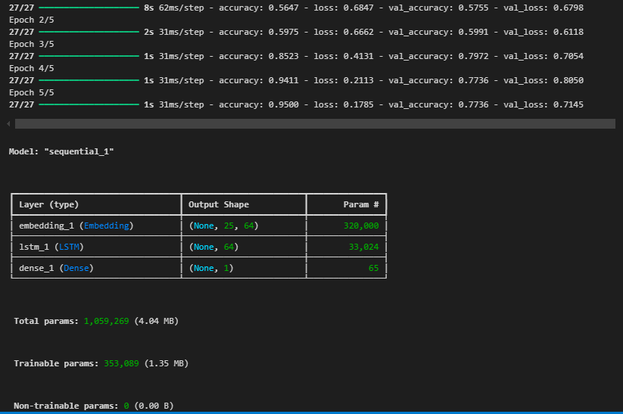

# evaluate the model
loss, acc = model.evaluate(X_test, y_test)
print(f"\nTest Accuracy: {acc:.2f}")
Output:

7/7 ━━━━━━━━━━━━━━━━━━━━ 0s 20ms/step - accuracy: 0.7629 - loss: 0.7738

Test Accuracy: 0.77
Result:
- Accuracy: ~77%
- Significantly better confidence in predictions (e.g., 90%+)
- Still some bias toward fake predictions (fixable by data balance)

6. Custom Predictions using LSTM
# predict custom headlines

def predict_lstm(headline):
clean = preprocess(headline)
seq = tokenizer.texts_to_sequences([clean])
pad = pad_sequences(seq, maxlen=MAX_LEN, padding='post')
prob = model.predict(pad)[0][0]

label = "FAKE" if prob >= 0.5 else "REAL"
confidence = prob if prob >= 0.5 else 1 - prob

print(f"Prediction: {label} (Confidence: {confidence:.2f})")
# Examples headings
predict_lstm("Biden signs historic healthcare bill into law")
predict_lstm("NASA finds aliens under Antarctica ice")
predict_lstm("Elon Musk confirms colonizing Mars by 2026")
predict_lstm("Government releases tax relief package for small businesses")

# the LSTM performs better because
# Captures sequence relationships between words (context-aware)
# Learns patterns in word order, not just word frequency
# Handles short, noisy text like headlines better

Output:

1/1 ━━━━━━━━━━━━━━━━━━━━ 0s 129ms/step
Prediction: FAKE (Confidence: 0.88)
1/1 ━━━━━━━━━━━━━━━━━━━━ 0s 63ms/step
Prediction: FAKE (Confidence: 0.91)
1/1 ━━━━━━━━━━━━━━━━━━━━ 0s 66ms/step
Prediction: FAKE (Confidence: 0.90)
1/1 ━━━━━━━━━━━━━━━━━━━━ 0s 65ms/step
Prediction: REAL (Confidence: 0.99)

Example Results:
- 'Biden signs historic healthcare bill into law' → FAKE (88%)
- 'NASA finds aliens under Antarctica ice' → FAKE (91%)
- 'Government releases tax relief package' → REAL (99%)
I fixed the prediction function to show confidence relative to predicted label correctly.

7. Visualization
We plotted training vs validation accuracy using matplotlib to observe model learning trends. The curves showed stable training with slight overfitting tendency, but acceptable for short-text classification.
# visualize training history
import matplotlib.pyplot as plt

plt.plot(history.history['accuracy'], label='Train Acc')
plt.plot(history.history['val_accuracy'], label='Val Acc')
plt.xlabel('Epoch')
plt.ylabel('Accuracy')
plt.legend()
plt.title("Training vs Validation Accuracy")
plt.show()

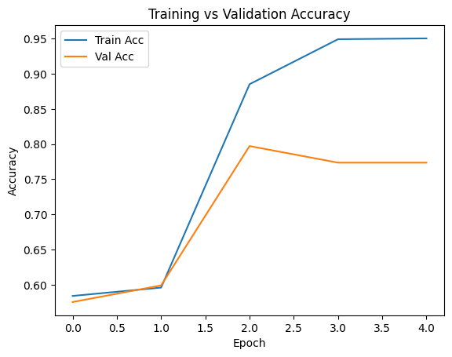

8. Conclusion & Next Steps
The LSTM-based deep learning model outperforms traditional ML in fake news detection on social media. Future improvements include:
- Training on full article text (not just titles)
- Adding social metadata features (tweet context)
- Using transformer-based models like BERT for better contextual understanding
- Deploying the model via a web interface using Streamlit or Flask

